ICBF2026 Meeting App created by Martina Bellio (Norwegian University of Life Sciences)
website https://mbel-tech.github.io/icbf-planner/
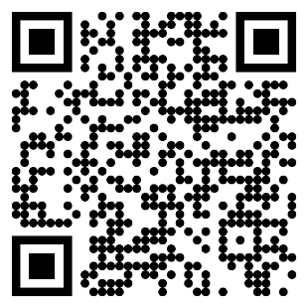
How to use the ICBF 2026 Planner
Open it with a double-click. It works fully offline — no internet needed once opened.

1. Switch view (optional)
On the start screen, there's a banner: "💻 Using a computer? → Open the desktop version". Tap it to switch to a wider, mouse-friendly layout in the same file. Desktop has a matching "📱 On your phone? → Switch to mobile" link.

2. Tell it if you're presenting
"Are you presenting a talk at ICBF 2026?"
- Yes → type your name as printed in the program (or just your surname). It searches every talk and shows matches with checkboxes — untick any that aren't you, then confirm. Those slots get auto-booked ("🎤 Your talk") and are skipped from the choice screens entirely.
- No → just proceeds as a regular attendee.
You can revisit and edit this anytime via the "edit" link once set.

3. Choose your days
Tap the days you're actually attending (Mon–Thu). Only those days appear in the planner and the final PDF.
4. Step through timeslots
Tap "Start planning". For each timeslot with parallel talks running in different rooms, you'll see one card per talk:
- Keep — mark a talk you might attend. You can keep up to 3 per slot if you're torn between rooms — they'll all appear in your final schedule as a "choose one" group, so you can decide on the day.
- ★ Star — flag a must-not-miss talk (also auto-keeps it).
- Skip — nothing in this slot interests you.

Breaks, lunches, poster sessions, and plenary talks are inserted automatically. Use the bottom bar's ◀ / ▶ to move between slots (swipe left/right also should work on mobile) or tap the agenda button to open a running summary of everything picked so far.

5. Review your schedule
When you finish (or tap "My schedule" early), you get the full personal agenda grouped by day — every kept talk, star, and auto-booked slot in order. Tap any entry to jump back and change it.

6. Export
- Download PDF — saves a clean personal schedule (time · room · title · presenter), with ★ and "Your talk" marked, and "choose one" noted for any multi-pick slots.
- On iPhone, if the download doesn't trigger automatically, use the "Open PDF" option instead, which opens it in a new tab so you can share/save via the iOS share sheet.
Everything is saved automatically as you go (in the browser's local storage), so closing and reopening the file picks up right where you left off.

